**Credit task 6.2 : System Modelling**

**Part 1: Domain Model**

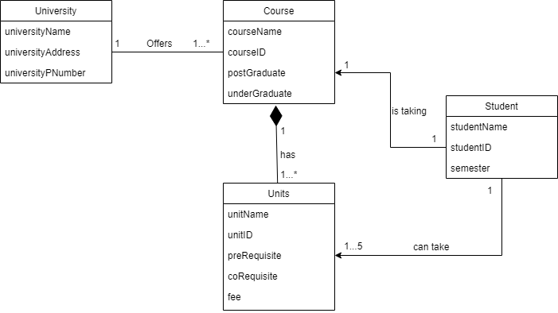

**Part 2: Models in software development project.**

Software development models are different processes or methodologies that are used in a project’s task or function and the method that is used is dependent on the software development team’s goals and objectives. There are different types of models like visual, non-visual, static and dynamic. An example of static would be the waterfall methodology and an example of dynamic would be the scrum method.

Models in software development project is important because it helps a software development team to plan, design, build, release and review a project. Choosing the right model is important as it can help a company or software development team to save time and money but still achieve the result that they want according to their objectives. Other than that, modelling also helps to draw out the blueprint of the project that we want to create. Modelling also allows us to design the pattern or how we want a system to be according to our objectives. Finally, modelling is important because it allows us to record down the decisions or changes that we have made on a system.

**Part 3: common / domain vocabulary**

Common / domain vocabulary is required as it helps to highlight the important elements, facts, relationships, and procedures in a software development project so that people who are not familiar with programming has a better understanding of what is happening in a software development project.

Example of 5 words from the context of the case study and their definition:

1. Course: A plan of study on a particular subject.
2. Unit: A single object or something part of a bigger object.
3. Student: A person who is studying in a school, college or university.
4. Semester: One of the periods into which a year is divided at college or university
5. Fee: A specific amount of money that is needed to be paid off for a particular object in this case a particular unit.

**Part 4:**

1. Eddie is enrolling for units that he wants in Swinburne University of Sarawak through their website.
2. 1) Alternatives: Eddie can go to Swinburne University of Sarawak physically and fill out the hard copy form from there to enroll into a unit.

2) Extensions:

1. Eddie enters his information wrongly.
2. System will check the information on the form submitted by Eddie and cross reference it to the database in Swinburne University of Sarawak.
3. System will signal an error to Eddie and request that he enter his information again.
4. Website is down for maintenance
   1. System will inform Eddie that the website to fill out the form for enrolling into a unit is under maintenance and request that Eddie try again later.
5. UseCase:
   1. Name: Eddie it trying to enroll into a unit.
   2. Primary actor: Eddie.
   3. Pre-condition: Eddie is a student in Swinburne University of Sarawak and his information is authenticated.
   4. Success guarantee: Eddie’s information is stored. A success message that says Eddie has successfully enrolled into the unit that he wants after all the information that Eddie entered has been checked and is valid.
   5. Main success scenario:
      1. Eddie fills out the online form that he obtained from the Swinburne University of Sarawak’s website to enroll into a unit.
      2. Eddie makes sure that his student information, units that he wants to enroll in, and the semester that he wishes to enroll in is correct before submitting it.
      3. System will check the information on the form that Eddie has submitted and verify all the information.
      4. System will then print out a success message that indicates Eddie has successfully enrolled into the unit that he wants.
   6. Extensions:
      1. Unit is not available for the semester
         1. System will alert Eddie that the unit that he wants to take is not available for the semester.
         2. System will prompt Eddie to refill the enrolment form again but with a different unit this time.
      2. Eddie submits the enrolment form after the due date
         1. System will check the enrolment form that is submitted by Eddie and verify all the information on it.
         2. System will print out a success message that indicates Eddie has successfully enroll into the units that he wants but with a note saying Eddie is required to pay the late penalty fee.
      3. Enrolment form is not filled out completely.
         1. System will print out an error message saying some of the required information is not filled out by Eddie.
         2. System will show Eddie which information that he has not filled out yet by highlighting the text box with the color red.
      4. Eddie has not paid the remaining fees from last semester.
         1. System will reject the enrolment form submitted by Eddie with a warning message saying that Eddie must pay the remaining fees from last semester before he could enroll into new units for this semester.
      5. Eddie could not load the enrolment form page.
         1. System will print out a message saying that the enrolment form page is not available.
         2. System will bring Eddie back to Swinburne University of Sarawak’s main website.

1. Class Diagram:

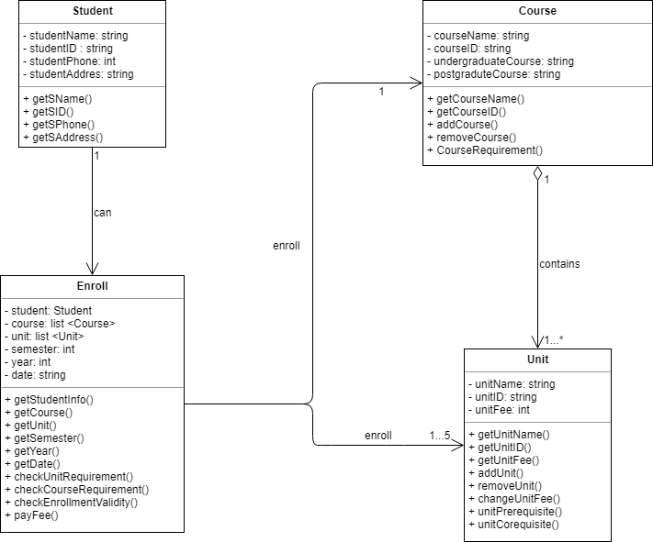

1. Activity Diagram: 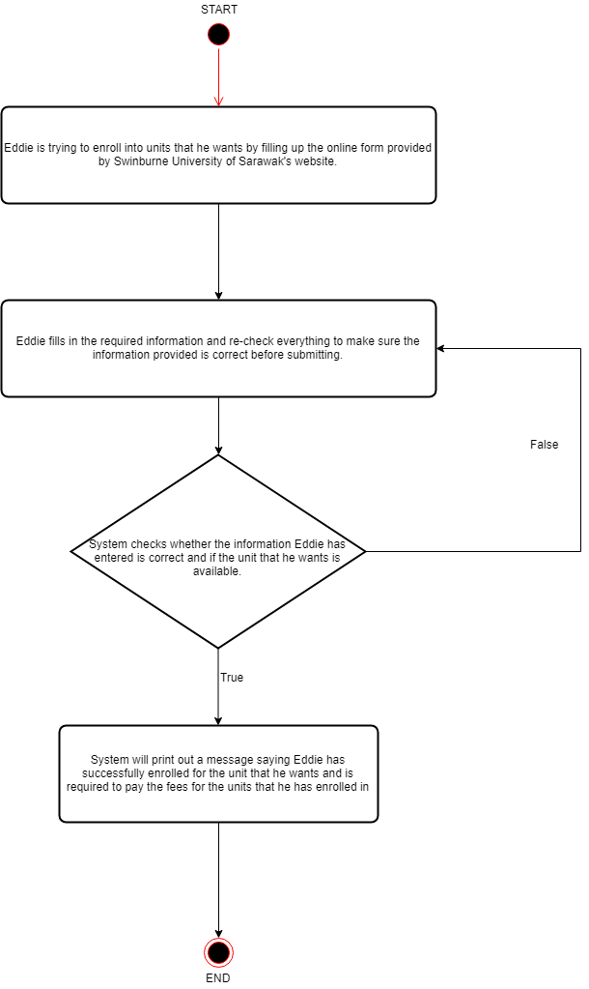

Resources used:

Boyd, NS 2009, *Domain Vocabulary*, Educery, viewed 20th April 2019,

<<http://educery.com/educe/patterns/domain-vocabulary.html>>

Activity Diagram - Activity Diagram Symbols, Examples, and More **n.d.**, *Activity Diagram*, smartdraw, viewed 20th April 2019,

<<https://www.smartdraw.com/activity-diagram/>>